Medical and Vocational Expert
User Guide
for

ERE: Access to Claimant’s
Electronic Folder



May 2016
Table of Contents

Overview 2
Requirements for ERE eFolder Access 2
Signing into ERE 2
Forgot Username or Password 3
Extra Security Sign In 3
Terms of Service 4
ERE Home 5
Access Claimant’s Electronic Folder 6
Electronic Folder Agreement 6
Unable to Access an eFolder 7
Access Suspended 7
Claimant eFolder 8
Exhibit List Options 9
Downloading Documents 10
New Case Search 10
Pick Up Files 10
Signing Out 10
Timing Out 10
Common User Errors 11
Access Keys 11

Overview

This guide provides Medical and Vocational Experts (ME/ VEs) with detailed instructions for viewing and downloading exhibited evidence in claimant’s electronic folders (eFolders).

Requirements for ERE eFolder Access

You meet the criteria for ERE eFolder access if you are a Medical or Vocational Expert (ME/VE) who has:
- Been awarded a Blanket Purchase Agreements (BPA) with the Social Security Administration (SSA)
- Received a favorable letter from the SSA Personnel Security & Suitability office
- Successfully registered for an Extra Security my Social Security account online through the ssa.gov official website
- Been assigned an Interrogatory and/or been scheduled to testify at a Hearing for a disability case

Signing into Electronic Records Express (ERE)

Sign into your ERE eFolder access account using this link - https://secure.ssa.gov/ERECA/MEVE01View.

You will sign in with the Username and Password you created when you registered for my Social Security. During sign-in, you must have handy the text-enabled cell phone you provided during my Social Security registration.

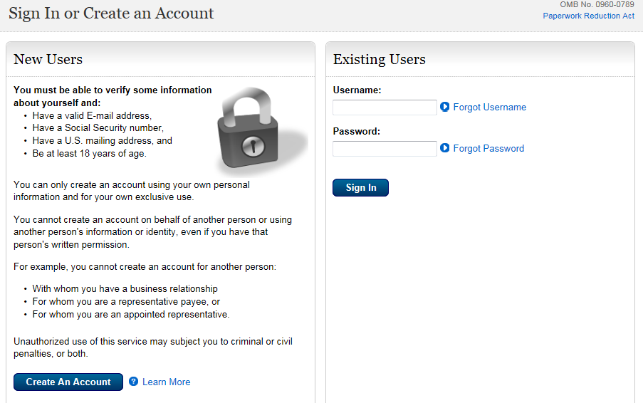

Forgot Username or Password

If you have forgotten either your Username or Password, select the Forgot Username or Forgot Password link on the Sign In screen, and follow the instructions.

Extra Security Sign In

You will receive a security code on the text-enabled cell phone number you provided during your my Social Security registration. Enter the security code and submit.

NOTE: Delete the text message after it is used. It is a one-time code and is valid for only 10 minutes.

IMPORTANT: Do not request to “disable extra security” because you will no longer be able to access claimants’ eFolders.

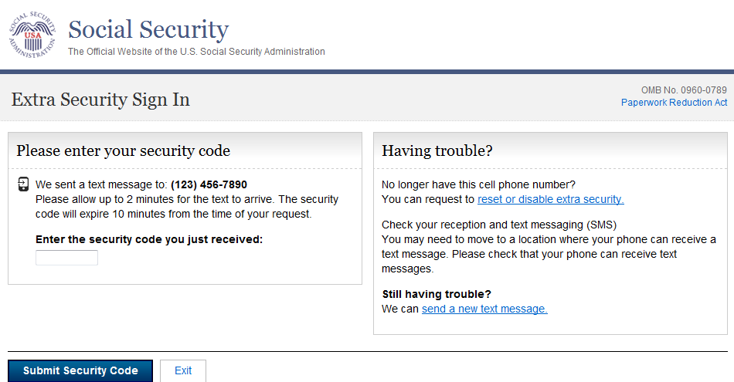

Terms of Service

You must read and agree to the my Social Security Terms of Service, then select Next.

NOTE: These Terms of Service apply to all my Social Security customers with personal accounts. You cannot access your personal my Social Security services (like Online Statement) when you sign in using the specialized ME/ VE link.

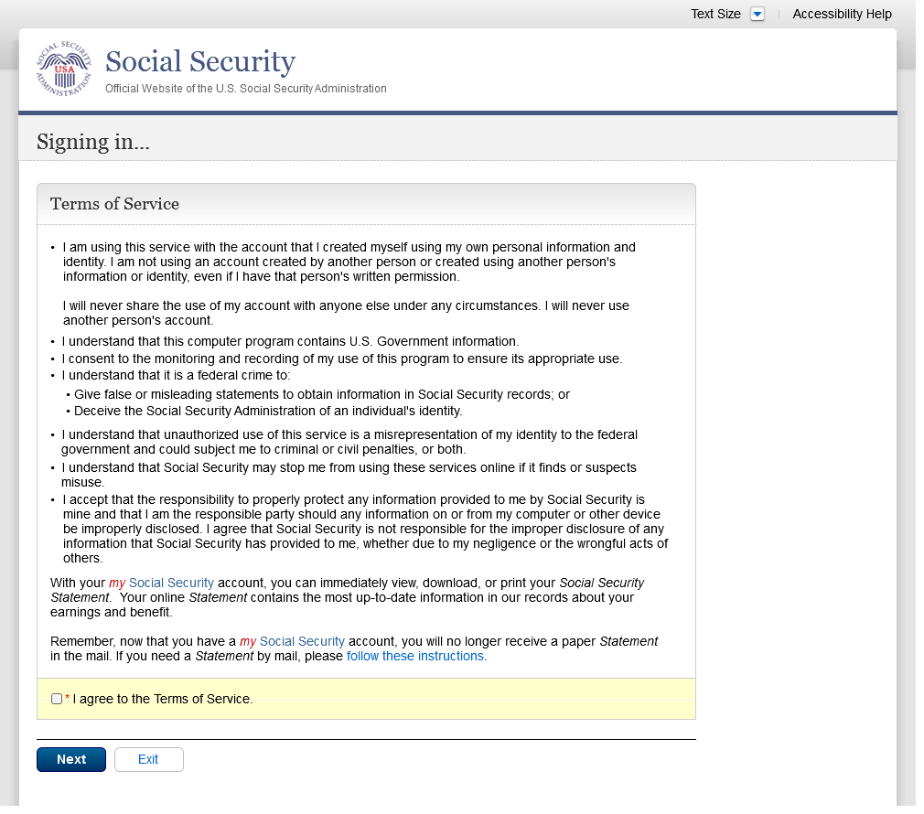

Electronic Records Express (ERE) Home

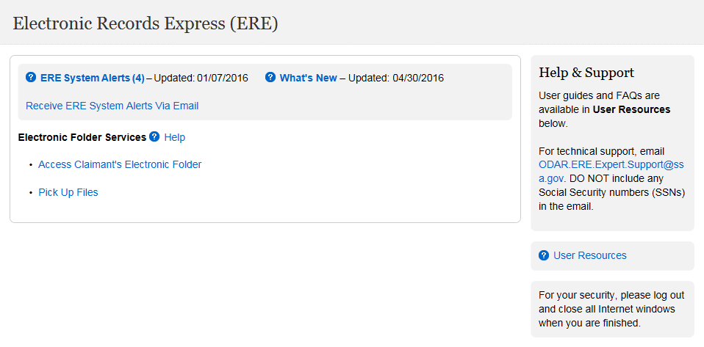

General ERE information is available to you on the ERE home page:
- ERE System Alerts notifies you of technical difficulties that may affect ERE performance.
- What’s New informs you of the latest changes and updates to ERE.
- Receive ERE System Alerts via Email allows you to receive automated ERE updates via email.

The following Electronic Folder Services features are available to you:
- Access Claimant’s Electronic Folder: select this link to view or download exhibited documents in the claimant’s eFolder.
- Pick Up Files: select this link to retrieve downloads requested from the eFolder.

Customer support tools are available:
- Help & Support: select the link to send an email to the help desk. Include your contact information, a description of the issue or question, and an applicable screen shot. DO NOT include Social Security Numbers in your email.
- User Resources: select this link for Frequently Answered Questions (FAQs), User Guides, and tips for customers with disabilities.

Access Claimant’s Electronic Folder

On the ERE home page, select the Access Claimant’s Electronic Folder link under Electronic Folder Services.

Electronic Folder Agreement

You must read the terms and conditions about ERE access, enter the claimant’s Social Security Number (SSN), and then select the I Agree button. You will find the claimant’s SSN on the notice we mailed to you.

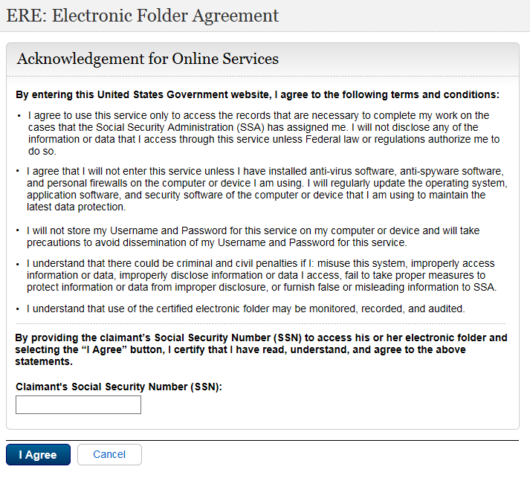

Unable to Access an eFolder

If you receive an Access Denied or Unable to Process Your Request message after entering the claimant SSN, the reason may be:

- You entered an incorrect SSN
- You are not assigned to this specific case
- The case is NOT electronic or pending at the Hearing level
- The Interrogatory has been received or the Hearing has been held

Verify that you entered the correct SSN and try again. If you receive another error message, we recommend you save a screen shot and email it, along with your contact information, to ODAR.ERE.Expert.Support@ssa.gov. Please DO NOT include SSNs in your email.

Access Suspended

We automatically suspend your ERE eFolder access account if you have 10 unsuccessful attempts when entering a claimant SSN. Once suspended, you will have to wait 24 hours for your ERE account to be automatically unlocked.

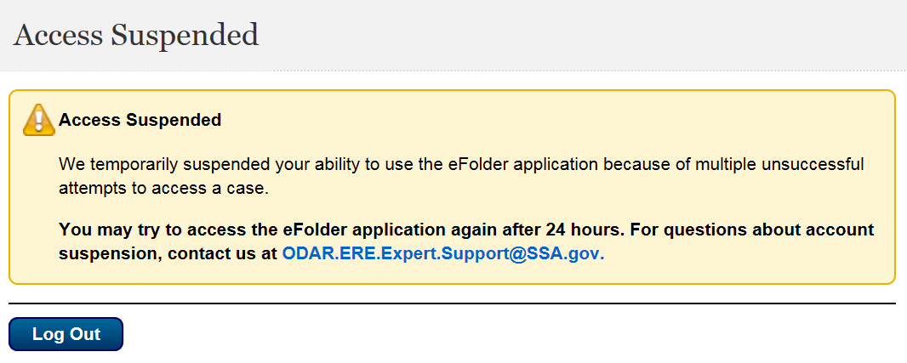

If you enter an incorrect SSN more than three (3) times, we recommend that you stop and send an email to ODAR.ERE.Expert.Support@ssa.gov . Do not include SSN’s in your email correspondence.

Claimant eFolder

The Electronic Folder contains a header that lists case-specific information: the claimant’s name and SSN, claim type and level, Hearing Office site code with jurisdiction of the case, and several pertinent dates.

The eFolder initially displays with all exhibits hidden. Medical and Vocational Experts have access to three sections of the eFolder:

- Section A. Payment Documents/ Decisions: Contains disability determination notices.
- Section E. Disability Related Development: Contains the Disability Reports, Vocational Reports, Medical Release forms, and Activities of Daily Living (ADL) forms.
- Section F. Medical Records: Contains all exhibited medical evidence from all levels of the disability claim (initial, reconsideration, and hearing).

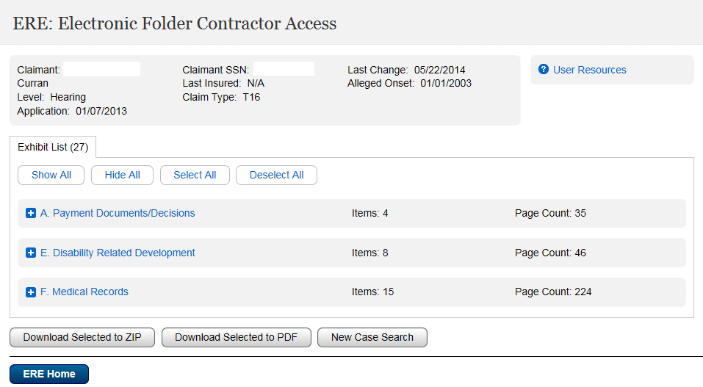

Exhibit List Options

View an Individual Document - You can open and view individual documents immediately by clicking on the description link.

Show All / Hide All - Select the Show All button to open all sections and display all documents. Select the Hide All button to close all sections.

Show/ Hide by Section – To the left of each section name is a blue square. Select the plus sign to open that section and display the documents. Select the minus sign to close that section.

Select All / Deselect All - Select these buttons to mark or unmark all documents in all sections. A selected document will be marked with a checkmark in the first column.

Select / Deselect Individual Documents – You can select / deselect individual documents by checking / unchecking the box in the first column.

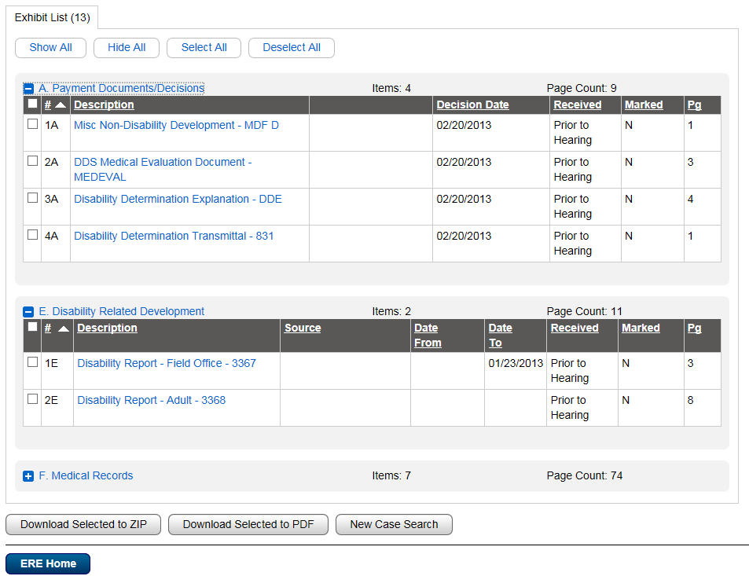

Downloading Documents

You can select documents from the eFolder to download and save to your personal or work computer.

Select documents to download by checking the box beside each individual document or by clicking the Select All button. If you are selecting many documents to download, we recommend you download them to ZIP or PDF. There is no difference in download times between PDF and ZIP files. Larger files may take up to 48 hours to download, but most download times are much faster.

You will receive the following message after you request a download:

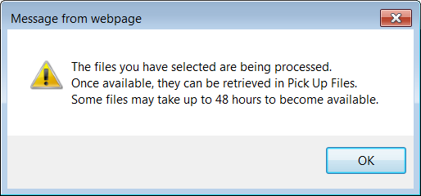

New Case Search

To access another claimant’s eFolder, select the New Case Search button. You will return to the Electronic Folder Agreement screen where you can enter another claimant SSN.

Pick Up Files

Return to ERE Home and select the Pick Up Files link to check the status of your download requests. See the Pick Up Files User Guide for detailed information.

Signing Out

To end your ERE session, select the Sign Out button. This button is located on the upper left on most screens.

Timing Out

ERE will automatically log you out:

- After 30 minutes of inactivity - This is a safeguard to protect your ERE eFolder access account and the claimant’s information. If this happens, you will have to sign into ERE again using the specialized link.

- After 2 hours of activity - This is another safeguard. If this happens, you will have to sign into ERE again using the specialized link.

Common User Errors

Errors can occur for many reasons. The following list briefly explains some common ERE customer errors:

- Bookmarking– Never bookmark screens within ERE. The only bookmark you should use for ERE is for the sign-in screen at https://secure.ssa.gov/ERECA/MEVE01View.
- Back Button - DO NOT use the Back button or “X” out of your Internet browser. You should always use the Sign Out button at the top left of the ERE screen.

Access Keys

ERE utilizes access keys to improve navigation and provide information. You will find a list of these keys in the table below:

Button/Link | Access Key
User Resources | u

Other keyboard commands, hotkeys or access keys will vary based on your browser and the version of the browser you are using. You can find a list of these commands in the Help section of your browser located on the Menu bar.
Assistive devices will also have a list of hotkeys or access keys in their Help section.

NOTE: To use the hotkeys or access keys, select the “Alt” or “Ctrl” button on your keyboard and the access key simultaneously.

