**Medical and Vocational Expert**

**User Guide**

**for**

**ERE: Pick Up Files**



**May 2016**

### **Table of Contents**

Overview 3

ERE Home 3

Pick Up Files 4

Ready for Download 5

Opening ZIP Files 5

Opening PDF Files 5

Signing Out 6

Timing Out 6

Common User Errors 6

Access Keys 6

### **Overview**

This guide provides Medical and Vocational Experts (ME/VEs) with detailed instructions for retrieving downloads requested from claimant’s electronic folders (eFolders).

Although large files may take up to 48 hours to download, most files are available much sooner. We encourage you to check **Pick Up Files** often for download status. Downloads are only available in **Pick Up Files** for seven (7) days after the download is complete.

### **Electronic Records Express (ERE) Home**

If you are not already logged into ERE for eFolder access, you must sign in using the specialized link <https://secure.ssa.gov/ERECA/MEVE01View> if you are not already logged into ERE.

On the ERE home page, select the ***Pick Up Files*** link under ***Electronic Folder Services***.

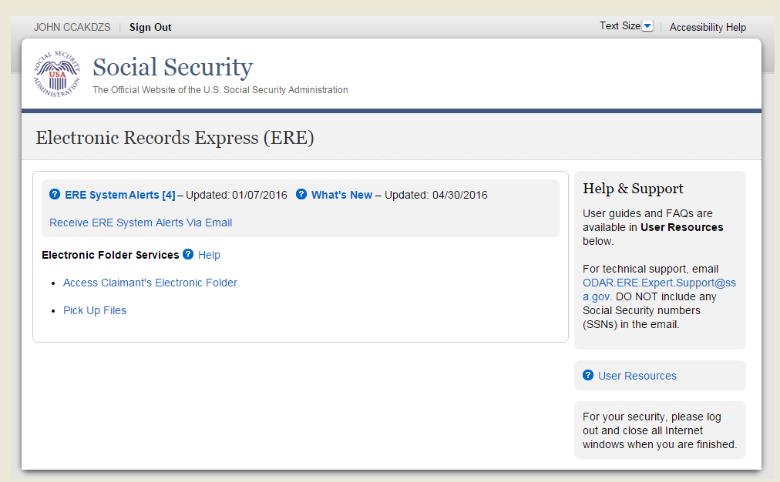

### 

### **Pick Up Files**

The table on this screen lists all claimant files you requested for download. You can identify the files by the last four digits of the claimant’s Social Security Number (SSN) and last name. The table provides information about file type, date and time of download request, and date and time we will automatically delete the file.

The table also shows the ***Status*** of the file download. ***Status*** options are:

* ***Ready for Download*** – these files can be downloaded on your personal/ work computer by clicking on the last 4 digits of the claimant SSN.
* ***Downloaded*** – these files have been downloaded by you already, but they remain available for seven (7) days.
* ***Processing***- these files have been requested but are not yet ready for download because we are converting them and creating either a ZIP or PDF package.
* ***Failed***- go back into the claimant eFolder and request these downloads again.

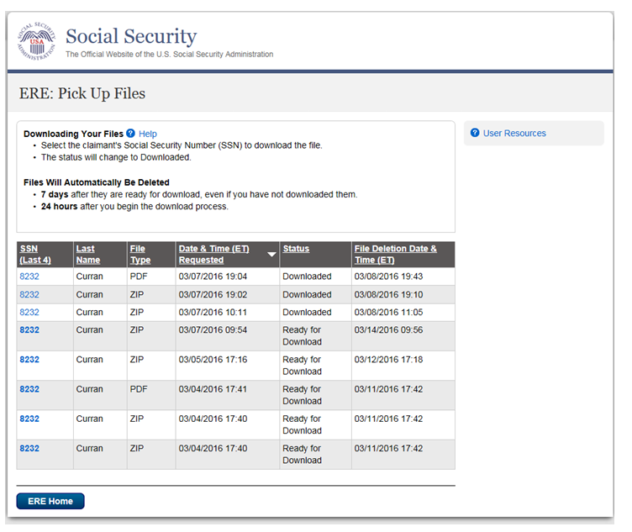

### **Ready for Download**

Select the claimant’s ***SSN (Last 4)*** link to download the file to your personal or work computer. A message box will display (may vary depending on your browser). ***Save*** the document to a desired location on your computer.

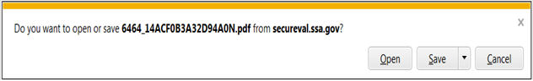

### 

### **Opening ZIP Files**

1. Go to the location where you saved the ZIP file and double click on the file to open it.
2. On the WinZip toolbar, select **Extract.**

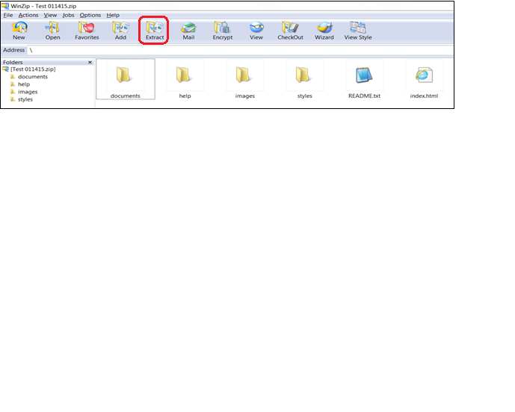

1. Save all the files/folders in the ZIP file package to the desired location on your computer.

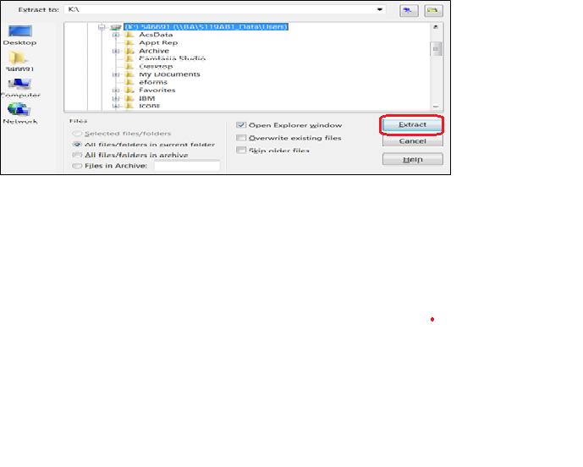

1. To view the documents, go to the location where you extracted the files and select the **index.html** file.

### **Opening PDF Files**

Go to the location where you saved the PDF file and double click on the file to open it.

### 

### **Signing Out**

To end your ERE session, select the **Sign Out** button on the upper left corner of the screen.

**Timing Out**

ERE will automatically log you out:

* After 30 minutes of inactivity - This is a safeguard to protect your ERE eFolder access account and the claimant’s information. If this happens, you will have to sign in again using the ME/ VE eFolder access link.
* After two (2) hours of activity - This is another safeguard. If this happens, you will have to sign in again using the ME/ VE eFolder access link.

**Common User Errors**

Errors can occur for many reasons. The following list briefly explains some common ERE customer errors:

* Bookmarking– Never bookmark screens within ERE.  The **only** bookmark you should use for ERE is for the sign-in screen at <https://secure.ssa.gov/ERECA/MEVE01View>.
* Back Button - DO NOT use the **Back** button or “X” out of your Internet browser. You should always use the ***Sign Out*** button at the top left of the ERE screen.

**Access Keys**

ERE utilizes access keys to improve navigation and provide information. You will find a list of these keys in the table below:

| **Button/Link** | **Access Key** |
| --- | --- |
| User Resources | u |

Other keyboard commands, hotkeys or access keys will vary based on your browser and the version of the browser you are using. You can find a list of these commands in the **Help** section of your browser located on the **Menu** bar.

Assistive devices will also have a list of hotkeys or access keys in their **Help** section.

**NOTE**: To use the hotkeys or access keys, select the “Alt” or “Ctrl” button on your keyboard and the access key simultaneously.