ERE
Submission Inquiry (SI)
Help Guide

Revision History
Date | Description | Author(s)
04/01/11 | Defect ID: 30  Section 5 Submission Status Codes - CDACK and CDACK_FL will not be valid status codes after the conversion to cyberfusion. Updated the note:  Note: This Status Code will be replaced by FECS_FL for submissions processes after the conversion to cyberfusion. | Mark Fost
03/01/11 | Defect ID: 300  The SI Guide document has been updated with the following changes:  Section 2.4.1 Submission Details – Main Results Screen – has been updated to include Routing Information and the values to be used . A new screen shot has been included with this update.  Section 5 Submission Status Codes – The following codes have been added  - FECS to replace CDACK  - FECS_FL to replace CDACK_FL  - This change will take place as of 4/9/11 and has been noted on the Description of the Codes for CDACK and CDACK_FL | Rivka Laks
02/16/10 | The “Last Updated” date was altered so that it is no longer dynamic on 02/12/10 by Dhaval Shah. | Rivka Laks

Table of Contents
1.0 Overview 4
1.1 Introduction 4
1.2 General System Information/Recommendations 4
1.2.1 Internet Browser 4
1.2.2 System Time Out 5
1.2.3 Optimal Viewing 5
1.2.4 Application Screen Buttons 5
2.0 SI Screens 6
2.1 Screen Navigation 6
2.2 Submission Inquiry – Search 7
2.2.1 Submission Inquiry – Search Fields 7
2.2.2 ERE SI Fields – Descriptions 8
2.2.3 Search Options/Criteria 9
2.2.4 Search Page Buttons and Navigation Links 10
2.3 Submission Inquiry – Results 11
2.3.1 SI Result Fields 12
2.3.2 To Sort the Results List 12
2.3.3 To View an Individual Result from the Results List 13
2.3.4 To Exit the Results Screen 13
2.4 Submission Inquiry – Submission Details 13
2.4.1 Submission Details – Main Results Screen 13
2.4.1.1 Submission Details – Main Results Screen Fields 15
2.4.1.2 Navigation Button 16
2.4.2 Submission Details-Secure Messaging Screen 16
2.4.2.1 Submission Details-Secure Messaging Screen Fields 17
2.4.2.2 Navigation Buttons 17
2.4.3 Submission Details – Secure Messaging Purged Submissions Screen 17
3.0 Support Information 18
4.0 ERE Application Type List 19
5.0 Submission Status Codes 21
6.0 File Status Codes 24

Activity Diagrams
Figure 1: SI Screen Pathing Chart 6
Figure 2: SI Search Screen 7
Figure 3: SI Results screen 11
Figure 4: SI Submission Details – Main Results Screen 14
Figure 5: SI Submission Details - Secure Messaging Screen 16
Figure 6: SI Submission Details – Secure Messaging Purged Submissions Screen 18

Overview

The ERE Submission Inquiry (SI) application has been designed to provide submission tracking information for the ERE (Electronic Records Express) application for ERE internal users. The application allows authorized users to view the status of submissions.

Users have the ability to select from multiple search criteria: Tracking Number, RQID (Request ID), Claimant SSN, Sender/User ID, Submission Status and the Original Filename.

The roles needed to access ERE SI Help Guide:
- ERE Administrator
- Regional Administrator
- Sponsor

The purpose of this document is to guide ERE SI users in how to perform and view a search submission. The help guide contains information about:

- General System Information/Recommendations
- SI Screens
- Support Information
- Application Type List
- Submission Status Codes
- File Status Codes

Introduction
The SI application is comprised of the following pages:
- Search Screen
- Results Screen
- Details Screen
    - Submission Details -Main Results Screen
    - Submission Details-Secure Messaging Screen
    - Submission Details-Secure Messaging Purged Submissions Screen

General System Information/Recommendations

Internet Browser
The SI application was developed using the SSA standard browser Internet Explorer (I.E. 7.0). There is no user browser detection in the application. (Since browser support is inconsistent for some web-based technologies, browser detection is commonly used to optimize browser performance.)

Users must have JavaScript enabled to ensure all search features are fully functional.

System Time Out
The SI application will have “time out” functionality after 30 minutes of inactivity. If a user returns to the SI application after 30 minutes of inactivity, the user will not be able to continue and previously selected search criteria will revert to the default selections.

Optimal Viewing
For optimal viewing, it is recommended that users set their screen resolution to 1024 x 768.

Note: The minimum screen resolution is 800x600.

Application Screen Buttons
The browser buttons should not be used to navigate through the SI application screens.

Users should only use the application screen buttons (e.g. Back to Search, Start a New Search, Back to Results) while in the SI application.

All application screen buttons in the SI application contain shortcut keys. Listed below are the shortcut keys to access various screens in the SI application.

SI Application Button | Keyboard Shortcut Keystrokes
Search | Alt + s
Back to Results | Alt + w
Back to Search | Alt + q
Start a New Search | Alt + v

SI Screens

Screen Navigation
The figure below shows the navigation of the SI screens.

The user submits search criteria from the Search page, and receives the Results page when there is data that matches the submitted criteria.

To receive a more detailed view of a particular submission, the user can select a Tracking Number link from the Results page.

The link will send the user to the one of three Submission Details screens depending on where the submission information resides:
- Submission Details Main Results Screen,
- Submission Details-Secure Messaging Screen
- Submission Details-Secure Messaging Purged Submissions Screen

Details Page Navigation Buttons
Returns to the Results Page

Back to Results

Returns to the Search Page with previously selected criteria.

Back to Search

Returns to blank Search Page

Back to Results

Submission Details Page-Secure Messaging

Submission Details Page-Secure Messaging Purged Submissions

Submission Details Page- Main Results

Results

Search

Clear

SI URL

Search

Back to Search

Start a New Search

Figure 1: SI Screen Pathing Chart

Submission Inquiry – Search
Once the user logs into SI, the Search page is displayed. The user enters search criteria on the Search page.

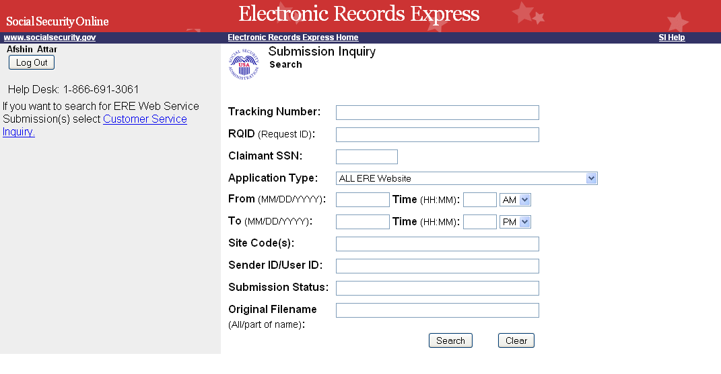
Figure 2: SI Search Screen

Submission Inquiry – Search Fields

The user can submit a search request after one or more of the following criteria have been entered:

- Tracking number
- RQID (Request ID)
- Claimant SSN
- Application Type
- From Date
  - Time (Eastern Time)
- To Date
  - Time (Eastern Time)
- Site Code
- Sender ID/User ID
- Submission Status
- Original Filename

ERE SI Fields – Descriptions

- Tracking Number: The Tracking Number is a unique number assigned to a submission. This field is case sensitive.

- RQID (Request ID): The RQID field is a case sensitive field. The Request ID is located on the request letter, near the barcode.

The Request ID shall be included for submissions made from July 26, 2008 onward. In addition, the Request ID is not available for responses submitted through bulk means (i.e. through Web Services, CE Scanned Signature, or Group Files).

- Claimant SSN: Searches may be made by entering the claimant’s Social Security Number.

Note: If a search returns too many records, no results are displayed. A screen will appear notifying the user that they must narrow their search criteria. If the Tracking Number, RQID or the SSN is not used for a search, please use the following fields to narrow your search criteria.

- Application Type: The type of ERE application such as:
  - ALL ERE WEBSITE (default)
  - Individual Medical Evidence Request (EREMER)
  - Consultative Exam (ERECE)
  - Secure Messaging (ERESM)

Note: See Section 4.0 for all Application Type Values

- From Date (Eastern Time): The start date when a search within a certain time period is to be performed.

- To Date (Eastern Time): The end date when a search within a certain time period is to be performed.

- Site Code: The user may search using multiple site codes. When entering multiple Site codes, each code must be separated by a comma (no spaces).

- Sender ID/User ID: A unique identifier for the person who made the submission. This field is case sensitive.

- Submission Status: A code that describes the status of the submission at a particular point in time. This field is case sensitive. Some status codes that may be useful in performing a search are listed in the chart below:

Status Code | Description
END | The status when ERE has successfully finished processing the submission.
END_FL | The status when ERE processing fails.
CNTCTD | The status when a problem occurs with the user uploaded document and the user has been contacted by ERE Tech support to make a new submission.
Note: See Section 5.0 for all submission status codes.

- Original Filename: The originally uploaded file name, including its extension. This field is case sensitive.

Search Options/Criteria
The following chart outlines details on the available search query combinations.

SI Search Query Combinations
Search Scenario | Required Data Elements | Optional Data Elements  (Any combination with  Required Data Elements)
1 | Tracking Number  Note: Once the user has entered this data all fields will become grayed out. | N/A
2 | RQID  Note: Once the user has entered this data all fields will become grayed out. | N/A
3 | SSN  Note: Once the user has entered this data all fields will become grayed out. | N/A
4 | Application Type*  + From Date and/or To Date | + Sender ID/User ID  + Submission Status  + Original Filename  + Associated Office Code
5 | Sender ID/User ID  + Application Type*  + From Date and/or To Date | + Submission Status  + Original Filename  + Associated Office Code
6 | Site Code  + Application Type*  + From Date and/or To Date | + Sender ID/User ID  + Submission Status  + Original Filename
7 | Submission Status  + Application Type*  + From Date and/or To Date | + Sender ID/User ID  + Original Filename  + Associated Office Code
8 | Original Filename  + Application Type*  + From Date and/or To Date | + Sender ID/User ID  + Submission Status  + Associated Office Code

* The default Application Type is ALL ERE WEBSITE. The user may decide to use this default or make another selection as desired.

Search Page Buttons and Navigation Links

Search: Allows the user to search based on the criteria entered. If all relational edits pass, the database will be searched and all submissions matching the entered criteria will be displayed on the Results page.

Clear: Clears all entries made by the user.

Log Out: Terminates the session and routes the user to the Login page.

Customer Service Inquiry: Routes the user to the Customer Service Inquiry application.

Submission Inquiry – Results
The Submission Inquiry Results screen is displayed once the search process has been successfully completed.

A maximum of 500 submissions are listed on the Results screen, with a maximum of 50 submissions displayed per page. If there are more than 500 results, a screen will appear requesting that the user narrows their search criteria.

Please refer to Section 2.2.3 for ways to refine your search.
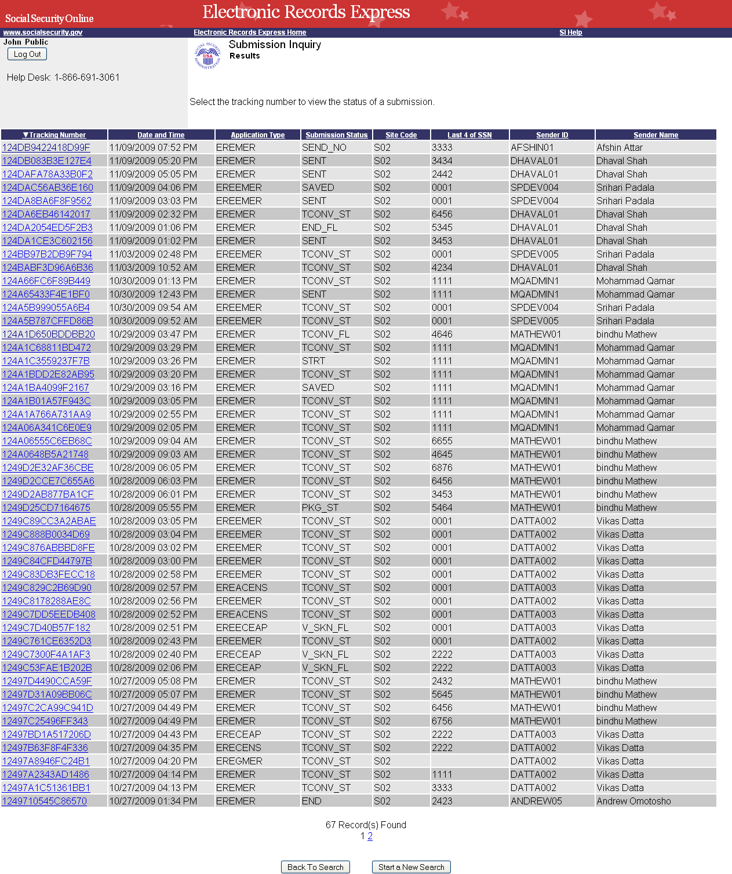
Figure 3: SI Results screen

SI Result Fields
The Results screen displays the following information about the submissions:

- Tracking Number: The Tracking Number is a unique number assigned to identify a submission.
- Date and Time: The date and the time (Eastern Time) the submission was downloaded to ERE.
- Application Type: The type of ERE application, such as:
    - EREMER (Individual Medical Evidence Request)
    - ERECE (Consultative Exam)
    - ERESM (Secure Messaging)
Note: See Section 4.0 for all Application Type values
- Submission Status: A value set that describes the current status of a submission.
Note: See Section 5.0 for the description of each status code
- Site Code: The Site Code related to the submission.
- Last 4 of SSN: The last four digits of the Claimant Social Security Number related to the submission, if available.
- Sender ID: The User ID of the person who made the submission.
- Sender Name: The name of the user who made the submission..
- Records Found: The total count of the submissions.

To Sort the Results List
The SI application allows the user to sort the results information by column.
The user may select a column by clicking on the column header. Once a column has been selected, the user will see either an up or down arrow directly to the left of the column header link. By clicking again on the column header link, the direction of the arrow will change. The direction of the arrow indicates the sort order.
- An up arrow will be displayed if the column is being sorted in ascending order.
- A down arrow will be displayed if the column is being sorted in descending order (for date fields: most recent dates at bottom).
The column containing the last four digits of the SSN will be sorted in numerical order by the last 4 digits.
When the search outcome is multiple Results pages and a new sort is made, all results in all the pages will be impacted by the sort option. The screen will display the first page of the new sort.
When there are more than 50 submissions returned for a search query, number links starting with one (1) and up to ten (10) will display at the bottom of the Results page. The numeric value(s) displayed indicates the total pages of results and can vary depending on the particular search result.

Since there are a maximum of 50 submissions displayed per page, the numeric value indicates the total number of pages with matching query results. The selection of a particular number will send the user to that page of results.

To View an Individual Result from the Results List
- From the Submission Inquiry – Results screen, select the desired Tracking Number text link with matching Date, Application Type, Submission Status, Last 4 of SSN, Sender ID and Sender Name information.

- The Submission Inquiry – Submission Details screen is displayed.
There are three types of Details screens:

- Submission Details – Main Results
- Submission Details – Secure Messaging
- Submission Details – Secure Messaging Purged Submissions

To Exit the Results Screen
The Results screen has three types of buttons:
- Log Out: Terminates the session and routes the user to the Login page.
- Back to Search: Takes the user to the Search page with the previously entered search criteria populated on the page.
- Start a New Search: Takes the user to a blank version of the Search page where the user may enter a new set of search criteria.

Submission Inquiry – Submission Details
Depending on the Tracking Number selected on the Results screen and its corresponding Application Type, one of the three Details screens shown in the following subsections shall be displayed.

Submission Details – Main Results Screen
The Submission Details – Main Results screen displays the following submission information:
- Tracking Number
- RQID (Request ID)
- Application Type
- Submitted Date (Eastern Time)
- Current Status
- Site Code
- Routing Information
        - Values: PRINT, DMA, PRINT/DMA
Note: As of 4/9/2011 all documents will be routed to DMA regardless of this value.
- Last 4 Digits of SSN
- Sender ID
- Sender Name
- Number of Files Uploaded
        - Number of files uploaded with the submission. Files include comments, and electronic signature.
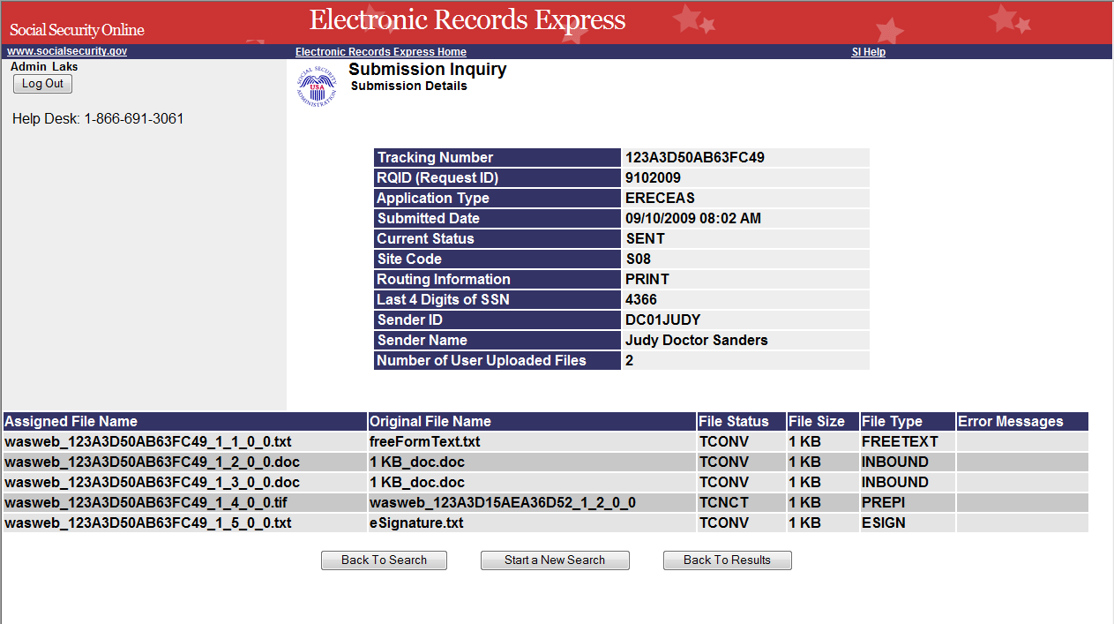
Figure 4: SI Submission Details – Main Results Screen

Submission Details – Main Results Screen Fields
The Submission Details – Main Results screen displays the following information about the associated files:
- RQID: This field will be blank for the ERE website.
- Assigned Filename: The ERE internal processing name given for this file.
- Original Filename: The name of the originally uploaded file, including its extension.
- File Status: A value that describes the current status of a file.
Note: See Section 5.0 for complete list of file status codes.
- File Size: The size of the file in bytes.
- File Type: The internal file classification based on the user’s submissions.
File Type | Description
FREETEXT | System-generated documents containing additional information entered by submitters
INBOUND | Files uploaded by submitters
PREPX | An Admin prepared the document and the Providers excluded it from the submission
PREPI | An Admin prepared the document and the Providers included it in the submission
ESIGN | System-generated documents created when providers select the check box to signify an electronic signature
NOREC | System-generated document indicating that no files were uploaded by the submitter
NOSHOW | System-generated document indicating that a claimant did not show up for his/her Consultative Exam
ZIPCHILD | Files within the submitted ZIP file
OUTBOUND | System-generated file for eFolder pilot
BTCHNAME | System-generated file that includes all the files uploaded by a submitter to Legacy System. This file will be prefixed with: veme.

- Error Message: This appears when an error occurs and the submission has failed or will fail. The error message displays the file status, then a colon, followed by system-generated error text (if any).
Note: Please refer to Section 5.0 for details about the possible errors and status codes.

Navigation Button
The Submission Details – Main Results page has four types of navigation buttons:
- Log Out: Terminates the session and routes the user to the Login page.
- Back to Search: Takes the user to the Search page, with the previously selected search criteria populated on the page.
- Start a New Search: Takes the user to a blank version of the Search page where the user can enter a new set of search criteria.
- Back to Results: Takes the user to the Results page. No data is saved.

Submission Details-Secure Messaging Screen
The Submission Details - Secure Messaging screen displays the following information about a submission:
- Tracking Number
- Application Type
- Submitted Date (Eastern Time)
- Current Status
- Sender ID
- Sender Name
- Number of Files Uploaded
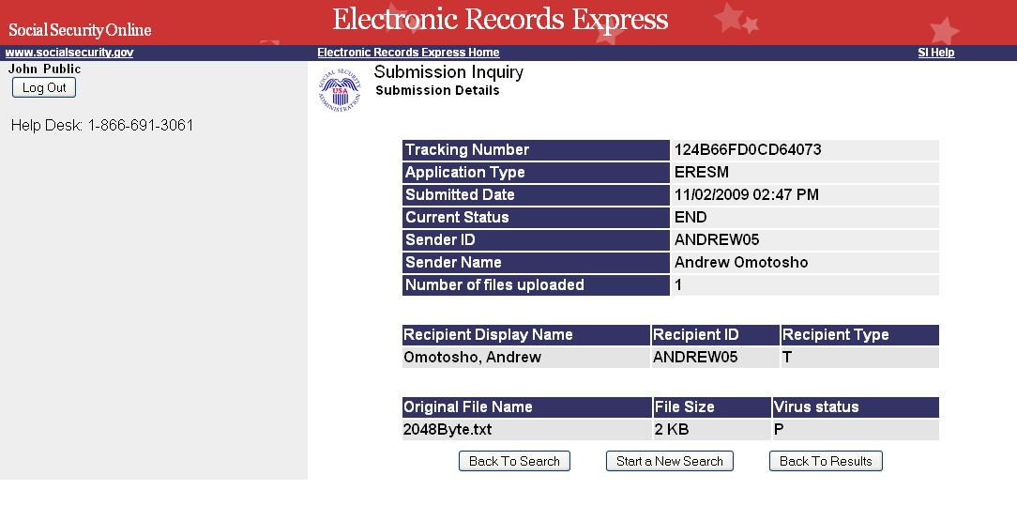
Figure 5: SI Submission Details - Secure Messaging Screen

Submission Details-Secure Messaging Screen Fields
The Submission Details – Secure Messaging screen displays the following information about the associated files:
- Recipient Display Name: The name of the user to whom the message was sent.
- Recipient ID: User ID of the person to whom the message was sent.
- Recipient Type: The code that identifies the recipient; Values can be T (to: recipient) or C (carbon copy (CC:) recipient).
- Original Filename: The name of the originally uploaded file (including its extension).
- File Size: The size of the file in bytes.
- Virus Status: The status indicating whether the file passed the virus scan or not; value is either P (pass) or F (failed).

Navigation Buttons
The Submission Details - Secure Messaging page has four types of navigation buttons:
- Log Out: Terminates the session and routes the user to the Login page.
- Back to Search: Takes the user to the Search page, with the previously selected search criteria populated on the page.
- Start a New Search: Takes the user to a blank version of the Search page where the user can enter a new set of search criteria.
- Back to Results: Takes the user to the Results page. No data is saved.

Submission Details – Secure Messaging Purged Submissions Screen
The Submission Details – Secure Messaging Purged Submissions screen is displayed for any Secure Message (associated with the Tracking Number selected) that has been purged from the system after exceeding its expiration date, but the record exists as displayed on the screen. The screen displays the following information about a submission:

- Tracking Number
- Application Type
- Submitted Date (Eastern Time)
- Current Status
- Sender ID
- Sender Name
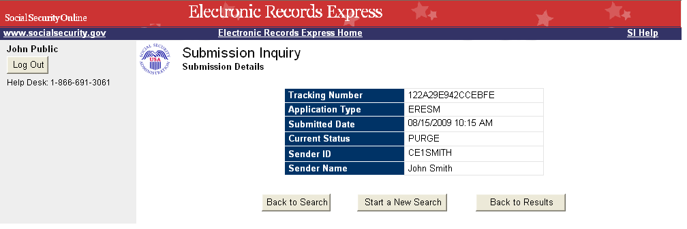
Figure 6: SI Submission Details – Secure Messaging Purged Submissions Screen
The Submission Details– Secure Messaging Purged Submissions page has four types of navigational buttons:
- Log Out: Terminates the session and routes the user to the Login page.
- Back to Search: Takes the user to the Search page, with the previously selected search criteria populated on the page.
- Start a New Search: Takes the user to a blank version of the Search page where the user can enter a new set of search criteria.
- Back to Results: Takes the user to the Results page. No data is saved.

Support Information

After a submission is processed, one of the following submission status codes may be displayed on the result and detail screens.

- END: The submission was successful.
- END_FL: If you see this status code for the first time, please note that the submission is being reviewed and allow some time before contacting ERE Tech Support.
- CNTCTD: Tech support has contacted the user to make a new submission.
Note: Any status codes other than those listed above mean the request is still being processed.

This guide explains all major technical details of the SI application. If you are experiencing application related problems, please contact tech support by e-mail: EETechSupport@ssa.gov

ERE Application Type List
Below is the Application Type drop-down list as shown from the SI Search screen. The default is ERE WEBSITE.

Application | Description
ALL ERE  WEBSITE | All submissions made through ERE Web Site application. (This does not include ERE Web Services)
EREACENS | Allows a CE Admin to submit a No Show CE report in response to an electronic request.
ERECE | A report uploaded after a requested medical exam has been performed by a medical provider (i.e., Providers). The provider must electronically sign the report
ERECEAP | Allows a CE Admin staff to prepare a CE report on behalf of a CE Provider in response to a non-electronic request.
ERECEAS | Allows a CE Provider to submit a CE report that was prepared by a CE Admin staff in response to a non-electronic request.
ERECENS | A Report uploaded indicating that a Consultative Exam was not done and provides an explanation
ERECESS | Allows a CE Provider to send a CE report with scanned signatures for multiple requests
ERECSPC | Allows a CE Billing Clerk on behalf of the CE Provider to submit a payment request. This function is available for a non-electronic request
ERECSPM | Allows a MER Billing Clerk on behalf of a MER Provider to submit a payment request. This function is available for a non-electronic request
ERECU | Allows a user to securely send a message with file attachments to ODAR office
EREDCENS | Allows a CE Provider to submit a No Show CE report in response to an electronic request.
EREECE | Allows a CE Provider to submit a CE reports in response to an electronic request.
EREECEAP | Allows a CE Admin staff to prepare a CE report on behalf of a CE Provider in response to an electronic request.
EREECEAS | Allows a CE Providers to submit the report that was prepared by a CE Admin staff in response to an electronic request.
EREECSPC | Allows a CE Billing Clerk on behalf of a CE Provider to submit a payment request. This function is available for an electronic request
EREECSPM | Allows a MER Billing Clerk on behalf of a MER Provider to submit payment requests. This function is available for an electronic request.
EREEFLDR | Allows an authorized representative to download packaged files from a claimant’s Electronic Folder.
EREEFMER | Allows an authorized representative to upload individual medical evidence when viewing a claimant’s Electronic Folder.
EREEMER | Allows a MER Provider to submit an individual’s medical evidence in response for electronic request.
EREEPRC | Allows a CE Billing Admin to prepare a payment request for CE providers. This function is available for an electronic request.
EREEPRM | Allows a MER Billing Admin to prepare a payment request for MER providers. This function is available for an electronic request.
EREEPSPC | Allows a CE Provider with Billing role to submit a payment request. This function is available for an electronic request.
EREEPSPM | Allows a MER Provider with Billing role to submit a payment request. This function is available for an electronic request.
EREERSPC | Allows a CE Provider with Billing Admin role to review and then submit a payment request that a CE Billing Admin prepared for them. This function is available for an electronic request.
EREERSPM | Allows a MER Provider with Billing Admin role to review and then submit a payment request that a MER Billing Admin prepared for them. This function is available for an electronic request.
EREGMER | Allows a user to send medical evidence from multiple request at once
EREMER | Allows a user to send individual medical evidence and enter required information from a request letter
EREPRC | Allows a CE Billing Admin to prepare a payment request for providers. This function is available for a non-electronic request.
EREPRM | Allows a MER Billing Admin to prepare a payment request for providers. This function is available for a non-electronic request.
EREPSPC | Allows a CE Provider with Billing role to submit a payment request. This function is available for a non-electronic request
EREPSPM | Allows a MER Provider with Billing role to submit a payment request. This function is available for a non-electronic request
ERERSPC | Allows a CE Provider with Billing Admin role to review and then submit a payment request that a CE Billing Admin prepared for them. This function is available for a non-electronic request.
ERERSPM | Allows a MER Provider with Billing Admin role to review and then submit a payment request that a MER Billing Admin prepared for them. This function is available for a non-electronic request.
ERESM | Allows ERE users to send messages through the secure web site.
ERESTRD | Allows transcription service personnel to send a transcribed CE report to the Provider.
EREWS | Allows high volume business partners to upload and submit electronic medical evidence to SSA via the internet.

Submission Status Codes
Status Code | Description
CNTCTD | The submission’s status when a problem occurs with the original submission and the user has been contacted by ERE Tech Support to make a new submission.
END | The submission’s status in the event of a successful and error-free submission and the file is ready to be picked up.
END_FL | The submission’s status in the event of an unsuccessful submission (due to a file or system error).
RJ_FTEND | The submission’s status when one or more of its file:  - is of zero-byte size  - exceeds the maximum allowable size  - is a rejected zip file
ADDPR | The submission’s status when all of the submission’s prepared files are successfully retrieved from the system.
ADDPR_FL | The submission’s status when one or more of the submission’s prepared files could not be retrieved from the system.
ADDPR_NO | The submission’s status when the submission does not have any prepared files.
CDACK | The submission’s status when an acknowledgement is received from the FECS server indicating that the FECS server has successfully received the submission and all associated files from ERE.  Note: This Status Code will be replaced by FECS_FL for submissions processes after the conversion to cyberfusion.
CDACK_FL | The submission’s status when an acknowledgement is received from the FECS server indicating that one or more files in the submission could not be received (due to a file or system error).  Note: This Status Code will be replaced by FECS_FL for submissions processes after the conversion to cyberfusion.
FECS | The submission’s status when an acknowledgement is received from the FECS server indicating that the FECS server has successfully received the submission and all associated files from ERE.
FECS_FL | The submission’s status when an acknowledgement is received from the FECS server indicating that one or more files in the submission could not be received (due to a file or system error).
INI_REQ | A submission’s initial status following the request for a Tracking number and prior to the saving of any file included with the submission.
PKG | The submission’s status when the submission’s uploaded files are successfully packaged.
PKG_FL | The submission’s status when one or more of the submission’s files could not be packaged (due to a file or system error).
PKG_NO | The submission’s status when the submission’s file(s) do not need to be packaged.
PREP | The submission’s status for a submission that is prepared by the Administrative staff and the submission and all associated files are successfully saved to the system.
PREP_FL | The submission’s status for a submission that is prepared by the Administrative staff could not be saved.
PREP_NO | The submission’s status when the submission’s prepared uploaded file(s) do not need to be saved (due to a file or system error).
purged | The submission’s status when the secure message associated with the given Tracking number is purged from the system.
RSTRT | The submission’s status when the submission has been manually restarted by ERE Tech Support because the initial submission failed (due to system error).
RSTRT_FL | The submission’s status when the submission was manually restarted and it cannot start the internal system processing.
RTRV | The submission’s status when the system has finished retrieving the documents requested by an appointed representative.
RTRV_FL | The submission’s status when the documents requested by an appointed representative could not be retrieved.
RTRV_ST | The submission’s status when the internal system processing starts to retrieve the documents requested by an appointed representative.
SAVED | If there are file(s) attached to the submission, the submission’s status is set to this value once all of the file(s) included with the submission have been successfully saved.
SEND_FL | The submission’s status when one or more of the submission’s files could not be sent (due to a file or system error).
SEND_NO | The submission’s status when submission’s file(s) do not need to be sent.
SEND_ST | The submission’s status when the submission starts sending files.
SENT | The submission’s status when the submission’s files are successfully sent.
STRT | The submission’s status when the internal system processing has started for this submission.
STRT_FL | The submission’s status when it cannot start the internal system processing.
TCNCT | The submission’s status when all of the submission’s uploaded tiff files are concatenated successfully.
TCNCT_FL | The submission’s status when one or more of the submission’s uploaded tiff files could not be concatenated (due to a file or system error).
TCNCT_NO | The submission’s status when the submission’s uploaded tiff file(s) do not need to be concatenated.
TCONV | The submission’s status when all of the submission’s uploaded files are successfully converted into tiff format.
TCONV_FL | The submission’s status when one or more of the submission’s uploaded files could not be converted into tiff format (due to a file or system error).
TCONV_NO | The submission’s status when none of the submission’s uploaded files are converted into tiff format.
TCONV_ST | The submission’s status when the submission starts the internal process of converting submitted files into tiff format.
UNZIP_FL | The submission’s status when one or more of the submission’s uploaded zip files, if any, are not successfully unzipped (due to a file or system error).
UNZIP_NO | The submission’s status when none of the submission’s uploaded files are zip files.
UNZIPPED | The submission’s status when all of the submission’s uploaded zip files, if any, are successfully unzipped.
V_SKN_FL | The submission’s status when one or more of the uploaded files in the submission fail the virus scan (i.e. has a virus) or the submission could not complete the virus scan process (due to a system error).
VIRS_SKN | The submission’s status when all uploaded files in the submission successfully pass the virus scan (i.e. have no virus).
FICNT | The submission’s status when the submitted file:  - has a valid zip extension  - contains files of type tiff or xml  - has less than 65 tiff files  - has exactly one xml file  - has no zero-byte file size.
TXN_RDY | The submission’s status fields are set to these values when the EFI transaction is ready to be sent to Legacy System.

File Status Codes
Status Code | Codes in Error Message field | Description
XXXX_FL | SYS_FL  TRKDB_FL | Any status ending with “_FL” (e.g. XXXX_FL) can have any of these two codes in the Error Message field indicating that a system error has occurred.
ADDPR |  | A prepared file’s status when it is successfully retrieved from the system.
ADDPR_FL |  | A prepared file’s status when it could not be retrieved due to a file error.
ADDPR_NO |  | A prepared file’s status when it does not need to be retrieved.
PKG |  | A file’s status when it is successfully renamed during packaging.
PKG_FL | FAIL | A file’s status when it could not be packaged due to a file-error.
PREP |  | A status for a file prepared by the Consultative Examination Administrator that is successfully saved.
PREP_FL | FAIL | A status for a file prepared by the Consultative Examination Administrator that could not be successfully saved (due to a file error).
RJ_ETYFL |  | A file’s status when it is rejected for having a zero-byte size or when one or more files are rejected for having a zero-byte size and neither the submission nor any file within the submission is rejected for exceeding the maximum allowable submission size.  (Example: Submission A has 3 files. File 1 has no errors, File 2 is zero byte and File 3 has no errors. Each file would have the status RJ_ETYFL and the submission does not exceed the maximum allowable submission size).
RJ_MAXFL |  | A file’s status when it is rejected for exceeding the maximum allowable size. All files (except zero byte files, and rejected zip files) in a submission will have their file status set to RJ_MAXFL when one or more individual files cause a submission to exceed the maximum allowable submission size.  (Example: Submission A has 3 files. File 1 has no errors, File 2 is zero byte and File 3 caused the submission to exceed the maximum allowable submission size. File 1 and File 3 shall have their file status set to RJ_MAXFL. File 2 shall have its file status set to RJ_ETYFL.)
RJ_ZIPFL |  | A zip file’s status when it is rejected for having at least one of the following errors:  - The file has a .zip extension but is not a zip file  - The zip file size is greater than zero-bytes, but does not contain any files.  - The zip file size is greater than zero-bytes, but the files that are within the zip file are of zero-byte size.  - The zip file has a directory depth greater than five.  - The zip file contains at least one file with an unaccepted extension.  In addition, all files in a submission will have their file status set to RJ_ZIPFL when one or more files are rejected for being a rejected zip file and neither the submission nor any file within the submission is rejected for exceeding the maximum allowable submission size nor is any file rejected for having a zero-byte size.
RSTRT_SV |  | The file’s status when the submission is restarted.
SEND_FL | FAIL | A file’s status when it could not be sent due to a file error.
SENT |  | A file’s status when it is successfully sent.
SV_FILE |  | A file’s status when all newly uploaded files for that submission are successfully saved.
TCNCT |  | A tiff file’s status when it is successfully concatenated with other tiff files.
TCNCT_FL | PMISMTCH | A tiff file’s status when it could not be concatenated with other tiff files due to a page mismatch.
TCNCT_FL | FAIL | A tiff file’s status when it could not be concatenated with other tiff files for any file-error not mentioned above (this is the default failure status).
TCONV |  | A file’s status when it is successfully converted into tiff format.
TCONV_FL | TYPFL | A file’s status when it has a file extension error.
TCONV_FL | OUT_NF | A file’s status when the output (tiff format) file is not found.
TCONV_FL | TIME_OUT | A file’s status when it could not be converted into tiff format because it times out after one hour of processing.
TCONV_FL | OUTMVERR | A file’s status when the output (tiff format) file cannot be moved to another folder for further processing.
TCONV_FL | TNFD | A status when the original file to be converted is not found.
TCONV_FL | PASSPROT | A file’s status when it cannot be converted since it is password protected.
TCONV_FL | FAIL | The default failure status for a file that could not be converted into tiff format (for any file-error not mentioned above).
TCONV_NO |  | A file’s status when it does not need to be converted since it is already a tiff file.
UNZIP_FL | ETYFL | A file’s status when the file, if it is a zip file, is not successfully unzipped since there are no files within the zip file.
UNZIP_FL | CFLE | A file’s status when the file, if it is a zip file, is not successfully unzipped since one of the children files has an error.
UNZIP_FL | ETYFL | A file’s status when it is removed from the zip file and found to have a byte size of 0.
UNZIP_FL | TYPFL | A file’s status when it is removed from the zip file and found to have a file extension error. (For example: .dco instead of .doc)
UNZIP_FL | DIRFL | A file’s status when it is found to be in a directory structure that is more than 5 levels deep. This status is only for a file that was extracted from a zip file.
UNZIP_FL | FAIL | A file’s status when the file, if it is a zip file, is not successfully unzipped for any file-error not mentioned above (this is a default failure status).
UNZIP_NO |  | A file’s status when the file is not a zip file and therefore is not unzipped.
UNZIP_SV |  | A file’s status when it is successfully removed from the zip file.
UNZIPPED |  | A file’s status when the file, if it is a zip file, is successfully unzipped.
V_SKN_FL | FAIL | A file’s status when it fails the virus scan (i.e. has a virus).
VIRS_SKN |  | The file’s status when it successfully passes the virus scan.

