Monthly Information Package

February 2025

Columns & Features

GENERAL ENROLLMENT PERIOD FOR MEDICARE PART B 2

YOUR PERSONAL MY SOCIAL SECURITY ACCOUNT IS FOR EVERY STAGE IN YOUR LIFE 3

SSA TALKS: SCAMS 4

5 THINGS TO KNOW WHEN YOUR CHILD WITH DISABILITIES TURNS 18 5

ARE YOU AGE 70 OR OLDER AND NOT YET RECEIVING BENEFITS? 6

Produced at U.S. taxpayer expense.

Social Security Column

# GENERAL ENROLLMENT PERIOD FOR MEDICARE PART B



If you did not apply for Medicare Part B (medical insurance) within 3 months before or after turning age 65, you have another chance each year during the General Enrollment Period. The period runs from January 1 to March 31 every year.

If you didn’t enroll in Part B when you’re first eligible, you may have to pay a late enrollment penalty for as long as you have Part B coverage. Your monthly premium will increase 10% for each 12-month period that you were eligible for Part B but did not sign up for it. Your coverage starts the first day of the month after you sign up.

To learn more about Medicare, please visit our Medicare Benefits page at [www.ssa.gov/benefits/medicare](https://www.ssa.gov/benefits/medicare/).

You may also read our Medicare publication at [www.ssa.gov/pubs/EN-05-10043.pdf](https://www.ssa.gov/pubs/EN-05-10043.pdf).

Please share this information with your friends and loved ones who may need it.

# # #

**Social Security Column**

# YOUR PERSONAL MY SOCIAL SECURITY ACCOUNT IS FOR EVERY STAGE IN YOUR LIFE



Your personal *my* Social Security account is here for you at every stage of your life. You don’t have to be retired or even close to retirement to take advantage of it. With an account, you can conduct much of your Social Security business online. For example, you can request a replacement Social Security card (in most states and the District of Columbia).

If you are not receiving benefits, you can use your personal *my* Social Securityaccount to:

* Get personalized retirement, spouse, or disability benefit estimates.
* Get your *Social Security Statement.*
* Get instant proof that you do not receive benefits.

If you already receive Social Security benefits, use your account to:

* Change your address. (Social Security benefits only)
* Change your direct deposit information. (Social Security benefits only)
* Get instant proof that you do receive benefits.
* Print your SSA-1099.

Please encourage your family and friends to create their personal *my* Social Security account at [www.ssa.gov/myaccount](https://www.ssa.gov/myaccount/).

###

**Social Security Column**

# SSA TALKS: SCAMS

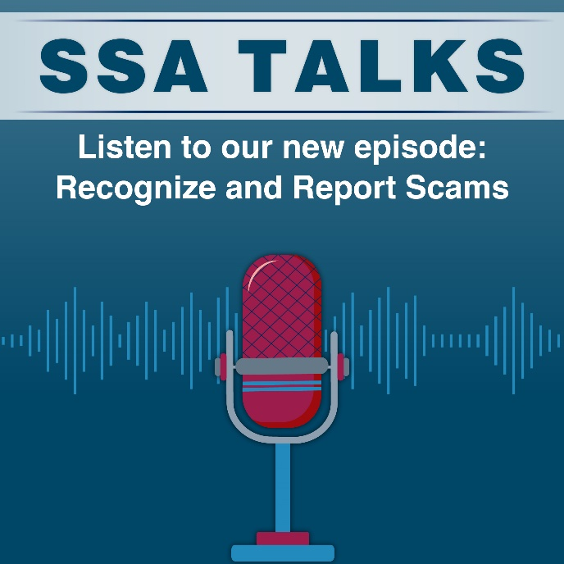

Rebecca Rose, Senior Public Affairs Specialist in SSA’s Office of Inspector General’s Division of Communications, joined episode 5 of ***SSA Talks*** to discuss Social Security scams and how to recognize them. Recognizing the signs of a scam gives you the power to ignore criminals and report the scam.

In this episode Rebecca discusses the 4 basic signs of a scam. She reveals that scammers will usually:

1. Pretend to be from an agency or organization you know to gain your trust.
2. Claim that there is a problem or that they have a prize.
3. Pressure you to act immediately.
4. Tell you to pay in a specific way such as gift cards.

The episode also includes testimony from scam survivor, Kate Kleinert. She's a widow who shares her story of losing $39,000 to a romance scam and offers advice on recognizing and reporting scams.

Our blog titled *What You Can Do To Protect Your Personal Information* at[blog.ssa.gov/what-you-can-do-to-protect-your-personal-information](https://blog.ssa.gov/what-you-can-do-to-protect-your-personal-information/)covers ways you can safeguard your personal information from scammers. To learn more about scams and how to report scams to our Office of the Inspector General, visit our Scams webpage at [www.ssa.gov/scam](https://www.ssa.gov/scam).

You can listen to this episode on our ***SSA Talks*** webpage at [www.ssa.gov/news/audio-series.html](https://www.ssa.gov/news/audio-series.html) and subscribe to receive alerts about future episodes. The ***SSA Talks***webpage contains a transcript for each episode.

Please share this information with your loved ones.

# # #

Social Security Column

# 5 THINGS TO KNOW WHEN YOUR CHILD WITH DISABILITIES TURNS 18

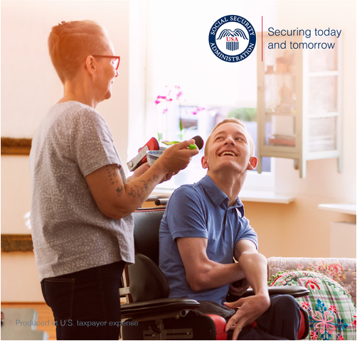

When your child turns 18 years old, they legally become an adult. This is an important time to consider their financial future – especially if they need additional care into adulthood. Here are 5 things that may help you prepare for this milestone:

## **1. Health and Welfare Decision-making**

When your child legally becomes an adult, you can no longer make certain decisions for them about their health and welfare. However, you can stay involved through **our Representative Payee program**. Social Security will determine who best serves as a representative payee for your child’s benefits. To learn more about the Representative Payee program, read our webpage at [www.ssa.gov/payee/index.htm](https://www.ssa.gov/payee/index.htm). Please note Social Security does not recognize power of attorney.

## **2. Changes in Supplemental Security Income (SSI) Eligibility**

SSI provides monthly payments to adults and children with disabilities, as well as people 65 and older, who have little or no income and resources.

If your child receives SSI, when they turn 18 we will review their eligibility for continued SSI payments based on the disability rules for adults. For more information, please review the publication, What You Need To Know About Your Supplemental Security Income (SSI) When You Turn 18 at [www.ssa.gov/pubs/EN-05-11005.pdf](https://www.ssa.gov/pubs/EN-05-11005.pdf). Please be sure to review this with your child. We also encourage you to check out Social Security’s Youth Toolkit webpage at [www.ssa.gov/youth](https://www.ssa.gov/youth/).

## **3. Education Transitions**

If your child attends school, they have a few options to continue their education, such as pursuing:

* **A diploma**: They may pursue further education in college or trade programs with an Individualized Education Program (IEP). More information on the IEP is available at [www.ssa.gov/pubs/EN-64-118.pdf](https://www.ssa.gov/pubs/EN-64-118.pdf).
* **A certificate**: They may have the opportunity to continue in a transitional program in their high school even after they complete their senior year. Most are permitted to remain until they turn 22.
* **Employment**: Local Vocational Rehabilitation Services can assist with employment options during pre-graduation IEP meetings.

## **4. Support for Living Arrangements**

Once your child turns 18, they may choose or qualify for different living arrangements depending on the services they already receive. If your child receives therapy services at school, how will they receive them once they leave? They could receive them through a Medicaid waiver or private insurance.

Qualification for respite services may also look different. Respite services allow family caregivers time to step away from their duties. It is essential you understand all the benefits and options available to your child after they complete high school and beforedeciding on living arrangements and services.

## **5. Financial Protections**

* **Special Needs Trust**: Update estate planning documents before your child turns 18. Otherwise, inheritance may terminate your child’s governmental benefits.
* **ABLE Account:** You can deposit funds into this account up to a certain limit each year. However, there are limits on what its funding covers. More information on ABLE accounts is available at [www.ssa.gov/payee/able_accounts.htm](https://www.ssa.gov/payee/able_accounts.htm).

*The above is informational only and does not constitute financial advice or an endorsement of ABLE products or ABLE organizations by the Social Security Administration. There may be other financial options that could be a better fit for some individuals. You must use your best judgement to determine which option is best for your situation.*

Children receiving benefits on a parent’s record may continue to receive those benefits until age 19 if they’re a full-time elementary or secondary school student. People who have a disability that began before age 22 may also be eligible to receive child’s benefits at any age. For more information, please review the publication, Benefits for Children at [www.ssa.gov/pubs/EN-05-10085.pdf](https://www.ssa.gov/pubs/EN-05-10085.pdf). As your child enters adulthood, consider these issues while you navigate their financial future.

Please share this information with your friends and loved ones who may need it.

# # #

Social Security Column

# ARE YOU AGE 70 OR OLDER AND NOT YET RECEIVING BENEFITS?



Retirement is not one-size-fits-all. It can mean different things to different people. Perhaps you have not applied for Social Security retirement benefits because you're still working or are delaying applying so you can get a higher benefit. If you’re age 70 or older, you should apply now for the benefits you’re owed. Your benefits will not increase if you continue to delay applying for them because you are 70 or older.

Did you know that you can receive benefits even if you still work? Your earnings can increase your monthly benefit amount – even after you start receiving benefits. Each year that you work, we check your earnings record. It’s possible your latest year of earnings is one of your highest 35 years. If so, we will automatically recalculate your benefit amount and pay you any increase due.

The best and easiest way to apply for your benefits is with a personal my Social Security account. You can create your free account at [www.ssa.gov/myaccount](https://www.ssa.gov/myaccount). Once you create your account, you can get an estimate of how much you might receive each month based on when you want to start receiving benefits and then apply.

In your account, you can also:

* Access publications – like our fact sheet for workers ages 70 and up at [www.ssa.gov/myaccount/assets/materials/workers-70andup.pdf](https://www.ssa.gov/myaccount/assets/materials/workers-70andup.pdf).
* Learn about benefits for your spouse and family members.
* Manage your benefits once you start receiving them.

We’re here to help you secure today and tomorrow and we invite you to learn more about applying for retirement benefits at [www.ssa.gov/apply](https://www.ssa.gov/apply/). Please share this information with those who need it.

*# # #*