**Social Security Column**

SSA TALKS: SCAMS

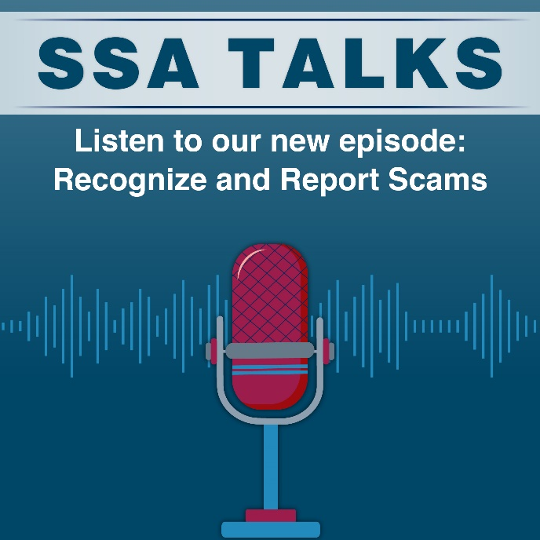

Rebecca Rose, Senior Public Affairs Specialist in SSA’s Office of Inspector General’s Division of Communications, joined episode 5 of ***SSA Talks*** to discuss Social Security scams and how to recognize them. Recognizing the signs of a scam gives you the power to ignore criminals and report the scam.

In this episode Rebecca discusses the 4 basic signs of a scam. She reveals that scammers will usually:

1. Pretend to be from an agency or organization you know to gain your trust.
2. Claim that there is a problem or that they have a prize.
3. Pressure you to act immediately.
4. Tell you to pay in a specific way such as gift cards.

The episode also includes testimony from scam survivor, Kate Kleinert. She's a widow who shares her story of losing $39,000 to a romance scam and offers advice on recognizing and reporting scams.

Our blog titled *What You Can Do To Protect Your Personal Information* at[blog.ssa.gov/what-you-can-do-to-protect-your-personal-information](https://blog.ssa.gov/what-you-can-do-to-protect-your-personal-information/)covers ways you can safeguard your personal information from scammers. To learn more about scams and how to report scams to our Office of the Inspector General, visit our Scams webpage at [www.ssa.gov/scam](https://www.ssa.gov/scam).

You can listen to this episode on our ***SSA Talks*** webpage at [www.ssa.gov/news/audio-series.html](https://www.ssa.gov/news/audio-series.html) and subscribe to receive alerts about future episodes. The ***SSA Talks***webpage contains a transcript for each episode.

Please share this information with your loved ones.

# # #