**Social Security Column**

OUR TOP SOCIAL MEDIA PAGES

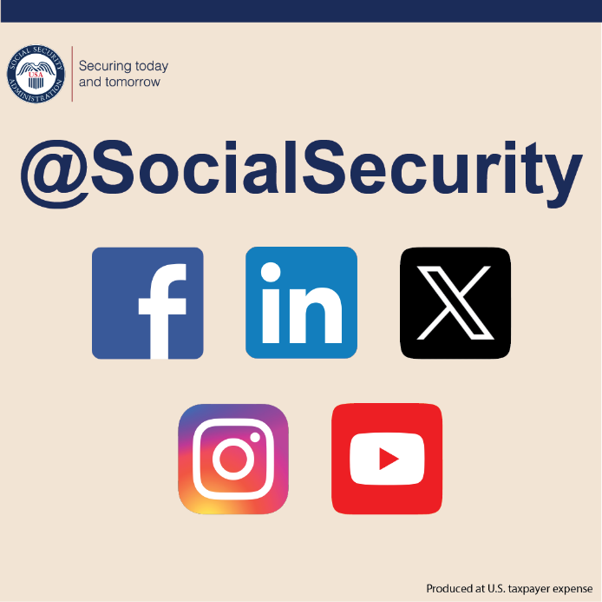

We strive to provide the public with accurate and helpful information. In addition to the resources available on our website at [www.ssa.gov](https://www.ssa.gov/), we post useful information on our social media channels. We invite you to learn about our programs and services on our social media pages:

* **Our Social Security Blog** – Here we post articles about our program, current events, and online services. We respond to general questions and comments people share. You can read our articles and subscribe at [blog.ssa.gov](https://blog.ssa.gov/). Our blog is now available in Spanish at [blog.ssa.gov/es](https://blog.ssa.gov/es/).
* **Facebook** – [www.facebook.com/socialsecurity](https://www.facebook.com/socialsecurity). Facebook is our primary page for sharing information about our programs and services with our vast network of followers and advocacy groups.
* **Administración del Seguro Social** – [www.facebook.com/segurosocial](https://www.facebook.com/segurosocial). Our Spanish Facebook page shares information about our programs and services.
* **X** – [www.x.com/socialsecurity](https://www.x.com/socialsecurity).*@SocialSecurity* is our official account. This page to provide timely information and updates about our programs and services with our followers and advocacy groups.
* **Seguro Social** – [www.x.com/segurosocial](https://www.x.com/segurosocial). On this page we share information about our programs and services in Spanish.
* **Instagram** – [www.instagram.com/SocialSecurity](https://www.instagram.com/SocialSecurity). Onthis page we share stories and resources that can help you and your loved ones.
* **YouTube** –[www.youtube.com/SocialSecurity](https://www.youtube.com/SocialSecurity). We have many informative videos on this page. Our videos cover online services, applying for retirement and disability benefits, Social Security-related scams, and much more. We also offer some of our videos in Spanish and other languages.

You can find a full list of our social media channels at [www.ssa.gov/socialmedia](https://www.ssa.gov/socialmedia/). Connect with us on social media to learn helpful information and ask general questions.**But remember, you should never post personal information on social media.** Follow along and share our pages with friends, neighbors, or loved ones today.

# # #