**Social Security Column**

SOCIAL SECURITY AND SCAM AWARENESS

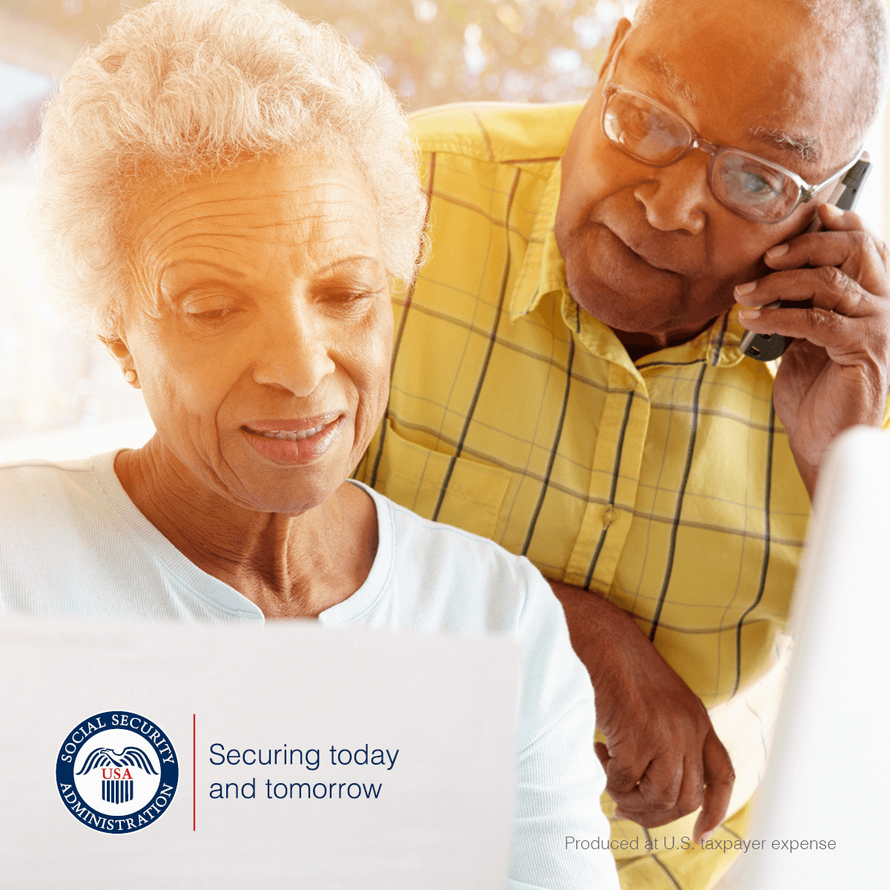

Social Security imposter scams continue to be widespread across the United States. Scammers use tactics to deceive you into providing sensitive information or money. If you receive a suspicious letter, text, email, or call, do not respond.

We will NEVER:

* Text or email images of an employee’s official government identification.
* Suspend your Social Security number.

Threaten you with arrest or other legal action unless you immediately pay a fine or fee.

* Require payment by retail gift card, wire transfer, internet currency, or cash by mail.

Promise a benefit increase or other assistance in exchange for payment.

Mail or email “official” letters or reports containing your personal information.

We only send text messages in limited situations, including:

* When you have subscribed to receive updates and notifications by text.
* As part of our enhanced security when accessing your personal *my* Social Securityaccount.

If you owe money to us, we will mail you a letter with payment options and appeal rights. Social Security employees do contact the public by telephone for business purposes. Ordinarily, the agency calls people who have recently applied for a Social Security benefit, are already receiving payments and require an update to their record or have requested a phone call from the agency. If there is a problem with a person's Social Security number or record, Social Security will typically mail a letter.

We encourage you to report suspected Social Security imposter scams — and other Social Security fraud — to the OIG’s website at [oig.ssa.gov/report](https://oig.ssa.gov/report/). You can find more information about scams at [www.ssa.gov/scam](https://www.ssa.gov/scam). Please share this information with your friends, family, and colleagues to help spread awareness about Social Security imposter scams.

# # #