**Social Security Column**

SOCIAL SECURITY’S SCHOOL EMPLOYEES AND SURVIVORS BENEFITS TOOLKITS

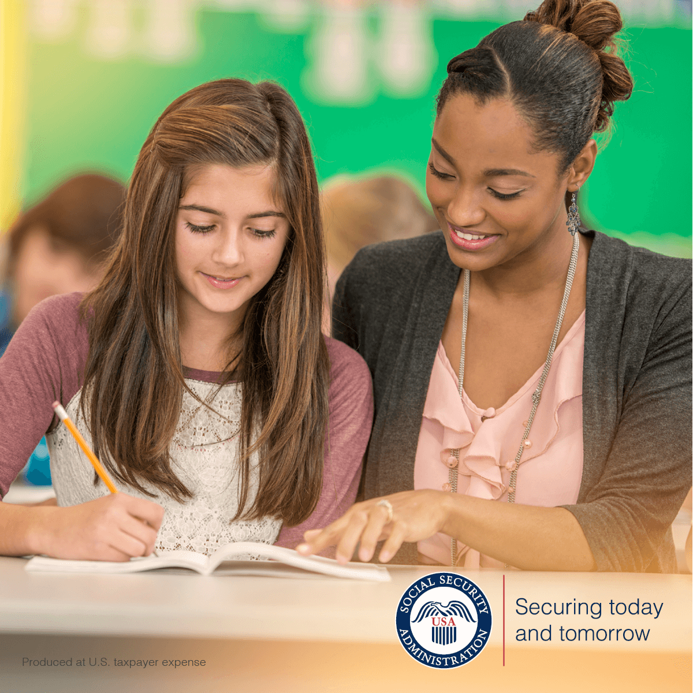

We’ve released new resources to help you better understand Social Security benefits. We’ve designed easy-to-use toolkits to provide education about our programs for children and our benefits for families after the death of a loved one. Our toolkits (**School Professional** and **Survivor Benefits**) are downloadable PDFs that include ready-to-go communications, such as sample email blasts, newsletter articles, handouts, and social media posts.

The **School Professional Toolkit** at [www.ssa.gov/marketing/assets/materials/toolkit-ss-benefits-and-ssi-payments-for-children.pdf](https://www.ssa.gov/marketing/assets/materials/toolkit-ss-benefits-and-ssi-payments-for-children.pdf) is for teachers, school counselors, and other educators. The purpose of this toolkit is to educate parents and guardians about the financial help we provide. We make payments to students with disabilities and to those who have experienced the loss of a parent or have a parent who is receiving retirement or disability benefits.

The toolkit discusses:

* Eligibility requirements.
* How to apply.
* How to respond to requests for school records and forms.
* Evidence we need from school professionals to determine whether a child with a disability may be eligible for SSI.

The **Survivors Benefits Toolkit** at [www.ssa.gov/marketing/assets/materials/toolkit-ss-survivors-benefit.pdf](https://www.ssa.gov/marketing/assets/materials/toolkit-ss-survivors-benefit.pdf) is for funeral homes, care facilities, and other organizations working with people who have lost a loved one. This toolkit increases awareness about survivors benefits for eligible family members. We make monthly payments to surviving spouses, minor children, adult children with disabilities, and dependent parents of workers who paid Social Security taxes before they died.

The toolkit discusses:

* Eligibility requirements.
* How to apply.
* Evidence we need to process applications.

For more information about our toolkits, visit the blog post titled *New Resources for School Employees and Survivors* at [blog.ssa.gov/new-resources-to-educate-school-employees-and-survivors](https://blog.ssa.gov/new-resources-to-educate-school-employees-and-survivors/).

Please help us spread the word about our toolkits with your colleagues and others who may find them helpful.

# # #